**UCCG System**

**Software Requirement Specification (SRS)**

**<2019.3.31>**

**Group 8**

**Prepared by**

**何朗轩 1730026028**

**李东华1730026039**

**李俊江 1730026044**

**余家慧 1730026139**

**Computer Science and Technology Program**

**United International College**

1. Table of Contents

1. Table of Contents 2

2. Introduction 3

2.1. Purpose 3

2.2. Project Scope 3

2.3. Document Conventions 4

3. System Features 5

3.1. For administration 5

3.2. For player 5

3.3. For all user 6

4. External Interface Requirements 7

4.1. User Interfaces 7

4.1.1. Common Characteristics 7

4.1.2. Administrative Pages 7

4.1.3. User Pages 8

4.1.4. Public Pages 10

4.2. Hardware Interfaces 11

4.2.1. Main supported devises and operating system 11

4.3. Communications Interfaces 12

5. Other Nonfunctional Requirements 13

5.1. Performance Requirements 13

5.2. Security Requirements 15

5.3. Software Quality Attributes 15

1. Introduction

## Purpose

This is a UCCG (UIC Cyber Game) Software Requirement Specification. The purpose of the document is let users agree on the requirements of the system that document specified, specify the requirement and functions and provide a basis for the following developing work. Normally, the document is a basic standard for inspection after product implementation, and the main reference document for testers when writing test cases. In addition, this document can also provide detailed descriptions of product requirements for other people who need to understand the system requirements.

## Project Scope

UCCG System is a multipurpose online OS (Operating System).

The target groups are: Game Players, Cyber Game Organizer and Cyber Game Judge.

The aim of this system is:

* Players can know the match arrangement, matching schedule, participants and participate the competition. Give player a way to know detail information of the UCCG.
* Players can register their teams online in order to avoid repeated application for the UCCG
* Cyber Game Organizer can create and change the rule of a match, arrange the matching time and post the arrangement online. Increase the degree of openness to UCCG participants and reduce the time costing.
* Cyber Game Judge can make a judge online which make UCCG more fair and transparent.

## Document Conventions

This document will be written using two different fonts, Arial for main content. Times new Roman for different levels of titles. Main content’s font size should be in 12pt.

1. System Features

## For administration

3.1.1 Description

There are two pages for administrator: information searching page and competition schedule edit page. Information searching page: administrator can search the information, such as the personal information of player and the record of the competition, etc. Competition schedule edit page: administrator can edit the schedule for each competition.

3.1.2 Functional Requirements

REQ-1: administrator have difference permissions and different permissions can do different things.

REQ-2: Senior administrator can edit the all information of the competition, but the referee administrator only can edit the score and publish or eliminate the player.

## For player

3.1.1 Description

There are two pages for staff: personal information inquiry page, registration page (for captain), and registration page (for team). Personal information page: player can find the personal information in this page and look for the schedule of the competition which he joined. Registration page (for captain): the page is only for captain and submit the registration of the competition team. Registration page (for team): the page is for the play to form a team.

3.1.2 Functional Requirements

REQ-1: player can see his name, slogan, profile, schedule, team, etc. in his/her personal information page.

REQ-2: a user can invite another user to form a team, and then the user can be the captain of the team. If the team want to join a competition, the captain can apply in the registration page (for captain).

## For all user

3.1.1 Description

There are six pages for all users: log in page, sign in page, retrieve password page, schedule preview page, index page. Log in page: the page is for the user to log in. Sign in page: the page is for the user to sign in. Retrieve password page: the page is for the user who forget his/her password to find the password back. Schedule preview page: user can see the schedules when the game is and search the schedule history. Index: the link for login in page, sign in page, schedule preview page, when user login, it will show the page links for the administrator if the user is administrator and will show the page links for play if the user is player.

3.1.2 Functional Requirements

REQ-1: administrator and user use a same login page.

REQ-2: sign in page only can sign in a player.

REQ-3: using email or phone number with the security verification problem can find back the password.

1. External Interface Requirements

## User Interfaces

### Common Characteristics

As the mentioned 10 webpages, they share the same characteristics as:

1. A navigation bar connecting pages in each group (Administrative Pages, User Pages and Public Pages), offering quick hyperlink to the other pages in the same group;
2. If they are directing opened by address (except the public pages), which means an un-login interview, the pages will automatically jump to the login page;
3. They are all full webpages and can suit any amount of display information (within 10000) from database;
4. They all have a block on their right top indicating the current login user and a logout button adjoint it. For the Public Pages, the block offers a login hyperlink to the login pages. After signing out, the pages will automatically jump to the home pages.

### Administrative Pages

For the Information Editing Page,

1. It allows the administrators to select a user or several users according to personalities such as name, ID, major, school year, participated evens and so on.
2. It allows the administrators to change the information of users by selecting an attribute and offering on-going changed information. For example, if a name of administrator needs to be changed, current name and new name should be provided
3. It allows the current administrator to modify a user to become a new administrator by changing the value of the Authority attribute

For the Competition Schedule Editing Page:

1. The administrators can edit the top 8 champion competition schedule. Each select box contains all the valid team name. If a team is defeated, the temp name will be darkened.
2. Each time this page update, the public competition schedule page is also updated

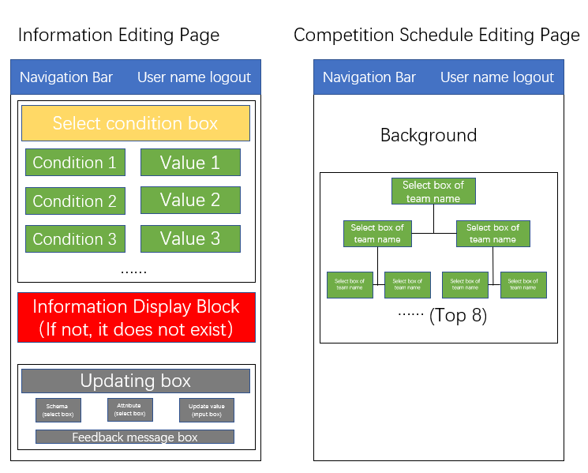

### User Pages

For the Personal information page,

1. The user can see his or her information in this page
2. The user can edit his or her personalities in this page by clicking the edit button. After clicking the Update button, the new information will be updated to the database
3. For a leader account, there is an additional block with input box and select box by which he or she can transfer his or her leader authority to anyone who is in his or her team.

For the Competition Sign Up Page (Only for team leaders),

1. The user can sign up the individual competition he or she will participate in. The user can also sign up the team competition as a team leader if and only if he or she has registered his or her team in the Team Registration Page and provide a team ID
   1. For a successful signing up, the feedback message will be displayed. And the team message with respect to the signed-up event will be displayed in the page ever later. But the pages still offer sign up for other events.
   2. For an unsuccessful signing up, red error message will be displayed. For example, if the team is banned by some reasons, warning message will be returned and displayed.
   3. For every signed-up event, there is an Give Up button to give up the event.

For the Team Registration Page,

1. Any account can register a team in this page only if the Team name is not duplicated. For a team, the account which registers it becomes the default leader of this team.
2. For any account, the user can see all the teams he or she has registered along with the information.
3. For a lead of a team, he or she can modify the team information and save it.
4. A user can register both as an individual team (for participating an individual event) or as a normal team (for team event) by select the radio box. Register as individual need less information than register as a leader of a normal team

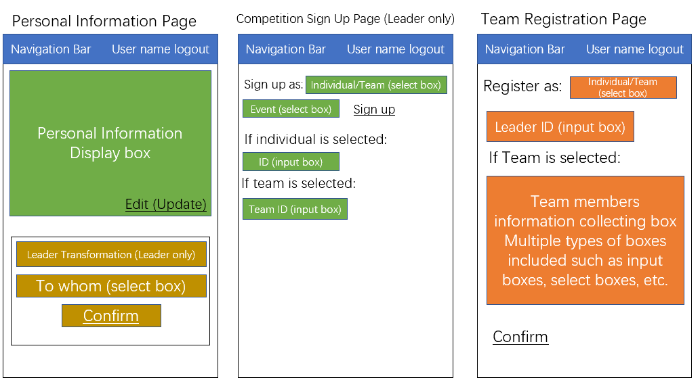

### Public Pages

For the Login in Page,

1. A user can login in his or her account by inputting account and password.
2. A user can jump to the Lost Account Page for resetting the passwords or finding the account
3. If an account login successfully, the pages will jump to the information pages with respect to its authority
4. If the password is incorrect, red error message will be return. The login will be frozen for 15 minutes if invalid logins occur for 5 times.

For the Registration Page,

1. A user can click the Register hyperlink in the Login page to jump to this page
2. The user can register an account by providing necessary information. Any lack of information will return a red error message by highlight the box of invalid information
3. Feedback message will be returned if the registration succeeds, and jump to the Home Page

For the Lost Account Page,

1. User can reset his or her password by providing answers of his security questions. Red error messages will be displayed if the answer is incorrect.
2. Each valid operation will be updated to the database

For the Competition Schedule Page,

1. This page only displays the schedule of the top 8 champion competition, which is edited by the administrator, the color of the knockout team will be darken

For the Home Page,

1. The Home Page of our website, display the information of our team including the events of competition, developers’ introduction, history review

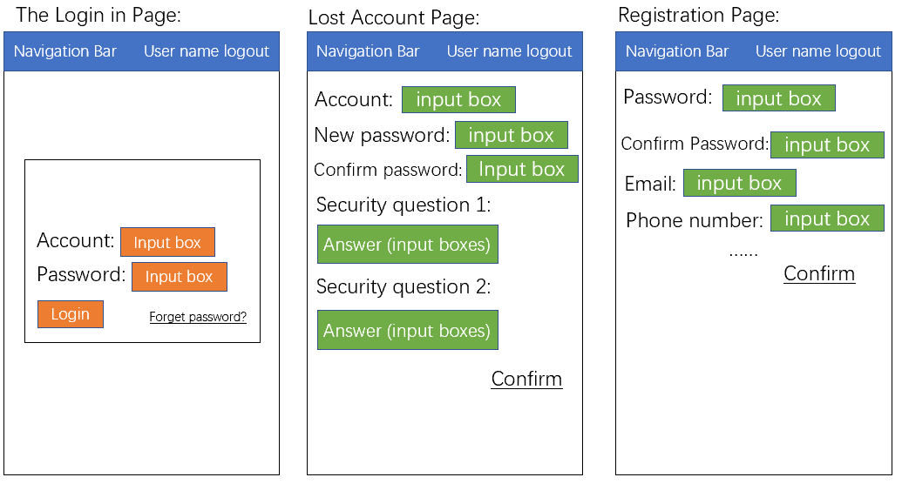

## Hardware Interfaces

### Main supported devises and operating system

The website supports browsers on Windows system

These browsers support HTML, JavaScript, CSS which are used in the Bootstrap frame in front-end of our pages. All the input messages from our user will be fetched by the Bootstrap with HTML and JavaScript. Then message will be sent to the back-end frame after a series of security checks and matching checks.

In the back-end of our page, we use flask frame which is written in Python. Almost all the data and message will be processed in this flack frame. Meanwhile, required data from MySQL will also be fetched to this frame for processing. After that, the returned messages will be passed to the front end and display to users and all the updated information will be sent to databases in MySQL for renewal.

As for database, we use MySQL with SQL to construct 9 schemas to store the information of user and competitions.

For registration an account in our website, e-mails of users are needed

## Communications Interfaces

Our website needs users’ e-mails for registration and follows the SMTP, POP3, IMAP4 standards

Our website is run on common browsers of Window system such as Chrome, Firefox, etc. It uses the FTP and HTTP standards.

The used network server communications protocol is the basic TCP/IP protocols.

1. Other Nonfunctional Requirements

## Performance Requirements

Nine entities are involved in the whole software, being listing belong:

User, Team, Cumulative Score, Participation Record, Event.

Down the User, there are Player, Judge, Administrator

Down the Event, there are Game.

Totally, the database can hold around 50,000 users.

The logical structure of the Data to be stored in the internal database is drawn below.

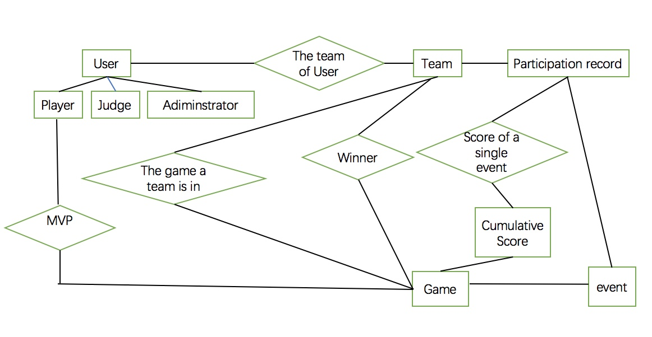

The data descriptions of each of these data entities is as follows:

**User Data Entity:**

|  |  |  |  |
| --- | --- | --- | --- |
| **Data Item** | **Type** | **Description** | **Comment** |
| ID | Integer | Unique Identity |  |
| Name | Text | Name of User |  |
| Email Address | Text | Internet address |  |
| Phone number | Text |  | May be several |

**Team Data Entity:**

|  |  |  |  |
| --- | --- | --- | --- |
| **Data Item** | **Type** | **Description** | **Comment** |
| ID | Integer | Unique Identity |  |
| Name | Text | Name of Team |  |
| Team Leader | Text | Name of Team Leader |  |
| Email Address | Text | Internet address |  |
| Phone number | Text |  | May be several |

**Cumulative Score Data Entity:**

|  |  |  |  |
| --- | --- | --- | --- |
| **Data Item** | **Type** | **Description** | **Comment** |
| ID | Integer | ID of Team or Player |  |
| Cumulative Score | Integer | Cumulative Score of the Team or Player |  |

**Participation Record Data Entity:**

|  |  |  |  |
| --- | --- | --- | --- |
| **Data Item** | **Type** | **Description** | **Comment** |
| Participant ID | Integer | ID of Team or Player |  |
| Event ID | Integer | Integer of Participation event |  |
| Score | Integer | Score of that event |  |

**Event Data Entity:**

|  |  |  |  |
| --- | --- | --- | --- |
| **Data Item** | **Type** | **Description** | **Comment** |
| Event ID | Integer | Unique Identity |  |
| Time | Integer | Happened time |  |
| Winner | Integer | ID of a team or participant |  |

## Security Requirements

The server on which the software resides will have its own security to prevent unauthorized *write*/*delete* access.

Only the Administrator will have physical access to the machine and the program on it. There is no special protection built into this system other than to provide the Administrator with *write/delete* access to the database to change data.

## Software Quality Attributes

Availability: The register process should be available on any time, providing people to participant into the event.

Correctness: The information page should be check regularly. In case of some emergencies happen, all users will be informed in time.

Usability: The software should satisfy a maximum number of users needs. In this case, it is 50,000 people.

Maintainability: The administrator should look through the software once a day, checking mistakes and failures, making sure its usability.